Created one directory



New Git repository in the current directory created

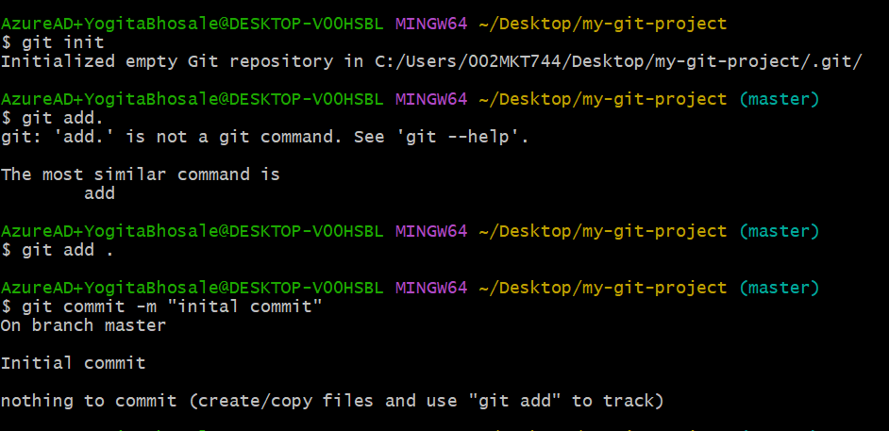

created a new branch

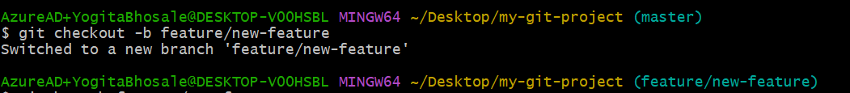

add the remote repository to your local repository

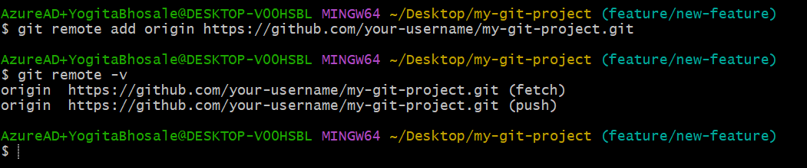

Created some files or data in local repository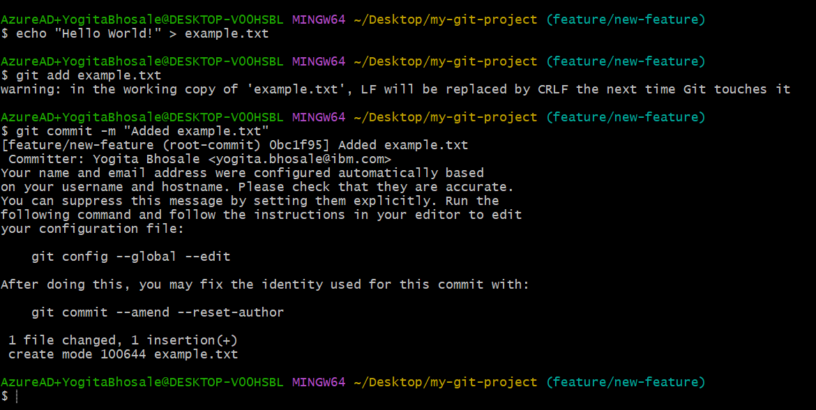

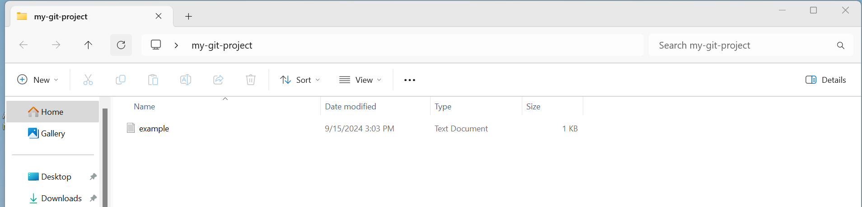

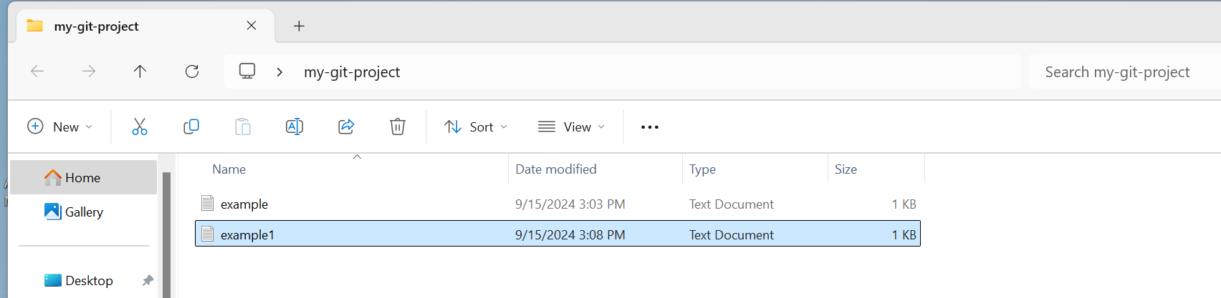

Push command: after push command checked with git log command to check the changes in the repository

Pull command

Delete command

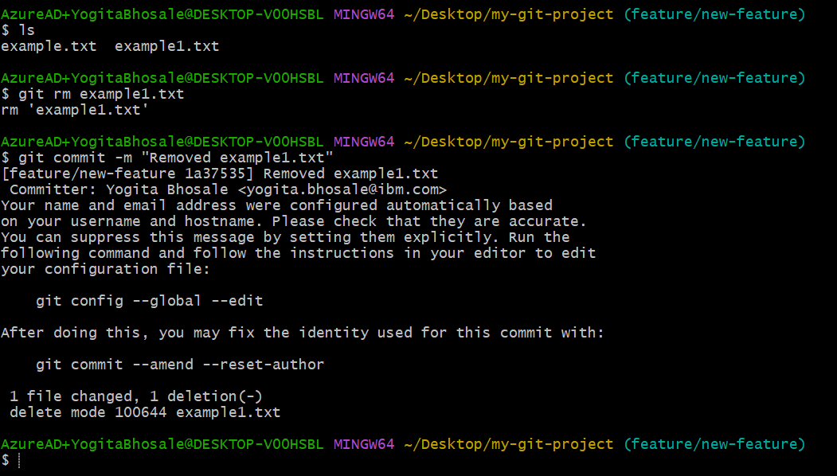

Merge command

